Learning Objectives:

- List the two types of barriers to communication and identify examples of each.

- Describe how senders and receivers can overcome communication barriers.

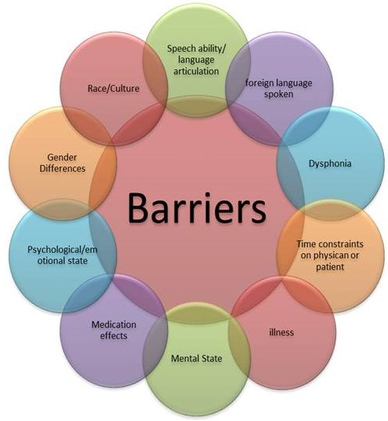
1.2 Overcoming Communication Barriers
Directions: Reflect on section 1.2 and respond to the following tasks.

Communication barriers are things or conditions that with communication.

Tasks 1 page 11 – Answer the following questions.
1. List the two types of barriers to communication and give examples of each.
1.
a.
b.
c.
2.
a.
b.
c.
Overcoming Barriers
2. Communication is a process between and .
3. The Sender’s Duties - The sender the communication process, he or she selects the for the message.
4. List the sender’s duties:
a. ________________________________________________
b. ________________________________________________
c. ________________________________________________
d. ________________________________________________
5. Audience analysis . All receivers are different, unique individuals.
6. When preparing for an audience analysis, list the factors below:
1.
2.
3.
4.
5.
7. Message Environment . The message environment affects how listeners receive a message. List three questions to consider in selecting a physical location.

a.
b.
c.
8. When selecting symbols and channels in the communication process. Each verbal and nonverbal symbol has a meaning to the receiver. If any of these meanings differ from those of the sender, this can be a to communication. Words and other symbols may have different meanings to people of different cultures.
9. feedback can help senders overcome barriers. Feedback can show that a listener does not understand the message.

10. List ways in which the sender could help deliver the message.
a.
b.
c.
d.
Tasks 2 page 15 – Answer the following questions
- What factors should you consider when creating an audience profile?

- How can get feedback help a sender?

Receiver’s Duties
11. The has a duty to aid the communication process by trying to overcome barriers. The receiver has more control over her or his part of the process than does the sender. The receiver’s duties are to and effectively.
is the process of seeing and interpreting written words and other symbols. A reader’s mental state of physical well-being can affect the ability to focus on a message.
is the process of hearing and focusing attention to understand an oral message. Gaining information from listening can be more challenging than from reading.

Task 3 page 17 – Answer the following questions
- What are a receiver’s duties in the communication process?

- Why may understanding a spoken message be more challenging than understanding a written message?

Task 4 - Checking for Understanding – Reading Skills
Read and follow the instructions as indicated on page 17. The Word file CH01 Reading is located in the data file folder on the desktop of your computer. 1. After reading the instructions, open the Word file CH01 Reading. 2. Key your name at the top of the document, 3. Space twice (DS) below the last paragraph and restate the main points of the message in your own words.

Section 1.2 Applications
A. Overcoming Communication Barriers – Read the instructions in the text.
1.
2.
3.
4.
5.
B. Audience Analysis – Read the directions in the text.

C. External Communication Barriers – Follow instructions in text and teacher.

Overcoming Communication Barriers Scoring
Open Questions 1 -11 35/ _________
Tasks 1 - 3 Questions 15/_________
Task 4 – Checking for Understanding 50/_________
Total Tasks 100/__________
1.2 A – Overcoming Communication Barriers 25/___________
1.2 B – Audience Analysis 50/ __________
1.2 C – External Communication Barriers 25/ __________
Total 1.2 ABC Applications 100/__________

